ASSIGNMENT- (0-1)

By: -

MANOSWINI PARIDA

CSE

1701297156

CONTENTS: -

# COMPUTER SYSTEM OVERVIEW

1.Language Processor

2.Example of famous libraries

3.ASCII

4.UNICODE

5.Compilation process vs Interpreter

# COMPUTATIONAL THINKING AND PYTHON INSTALLATION (ANACONDA)

1.Decomposition

2.Pattern Recognition

3.Abstraction

4.Algorithm

# PYTHON FUNDAMENTALS

1.Tokens

2.Python program

3.Python styles rules and conventions

4.Variable and Assignments

5.Input and Output

# DATA HANDLING

1.Data types

2.Mutable and Immutable

3.Operators

4.Working with Libraries

A) Computer System Overview:

1.Language processor: -

Nowadays, most programs are written in a high-level language such as C, Java, or Python. These languages are designed more for people, rather than machines, language processor is a software program designed or used to perform tasks such as processing program code to machine code.

There are three types of language processor: -

1. Assembler: -Converts high level code to machine level code.
2. Interpreter: - Line by line execution of a program.
3. Compiler: - It compile whole program at a time.

2.Some Important libraries: -

a) NumPy: -

It is a library for the Python programming language, adding support for large, multi-dimensional arrays and matrices, along with a large collection of high-level mathematical functions to operate on these arrays. You should use a NumPy array if you want to perform mathematical operations. Additionally, we can perform arithmetic functions on an array which we cannot do on a list.

b) SciPy: -

SciPy is a library that uses NumPy for more mathematical functions. SciPy uses NumPy arrays as the basic data structure, and comes with modules for various commonly used tasks in scientific programming, including linear algebra, integration (calculus), ordinary differential equation solving, and signal processing.

c) Pandas: -

(**Pediatric Autoimmune Neuropsychiatric Disorders Associated)**

In computer programming, pandas are a software library written for the Python programming language for data manipulation and analysis. In particular, it offers data structures and operations for manipulating numerical tables and time series. It is free software released under the three-clause BSD license.

3.ASCII: -

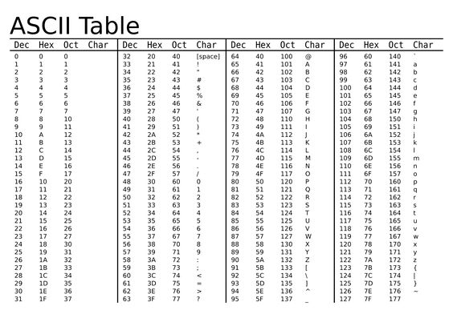ASCII stands for American Standard Code for Information Interchange. It is a method to define a set of characters for encoding text documents on computers. The ASCII codes represent computers and other communication devices that use text.

4.Uni code: -

(It stands for Universal trunk-out-of-service CODE)

Unicode is a universal character encoding standard. It defines the way individual characters are represented in text files, web pages, and other types of documents. While ASCII only uses one byte to represent each character, Unicode supports up to 4 bytes for each character

.

B) Computational Thinking & Installation of Python: -

# There are 4 diff techniques of computational thinking: -

**1. Decomposition: -**

Decomposition is the part of computational thinking. Where it involves breaking down a complex problem or system into smaller parts that are more manageable and easier to understand. The smaller parts can then be examined and solved, or designed individually, as they are simpler to work with.

**2. Pattern Recognition: -**

Pattern recognition can be defined as the classification of data based on knowledge already

gained or on statistical information extracted from patterns and/or their representation. It was the main part of the machine learning.

**3. Abstraction: -**

Abstraction is selecting data from a larger database to show only the relevant details to the object. It helps to reduce programming complexity and effort. Abstraction is related to both encapsulation and data hiding.

**4. Algorithms: -**

  An algorithm is a set of instructions designed to perform a specific task.

# Python installation: -

It can be done in 3 diff. ways;

* Python Org.
* Python gives some more IDE (INTEGRATED DEVELOPMENT ENVIRONMENT)
  + Like Anaconda (<https://www.anaconda.com/distribution/>)
  + PyCharm (<https://www.jetbrains.com/pycharm/>)
  + Vs Studio

C) Python fundamentals: -

There are diff. fundamentals in pythons are:

STATEMENT: -

Python statements are nothing but logical instructions that interpreter can read and execute. It can be both single and multiline.  
There are two categories of statements in Python:

1. Expression statements: -

With the help of expressions, we perform operations like addition, subtraction, concentration etc. In other words, it is a statement that returns a value. It is an expression if it appears-

1. 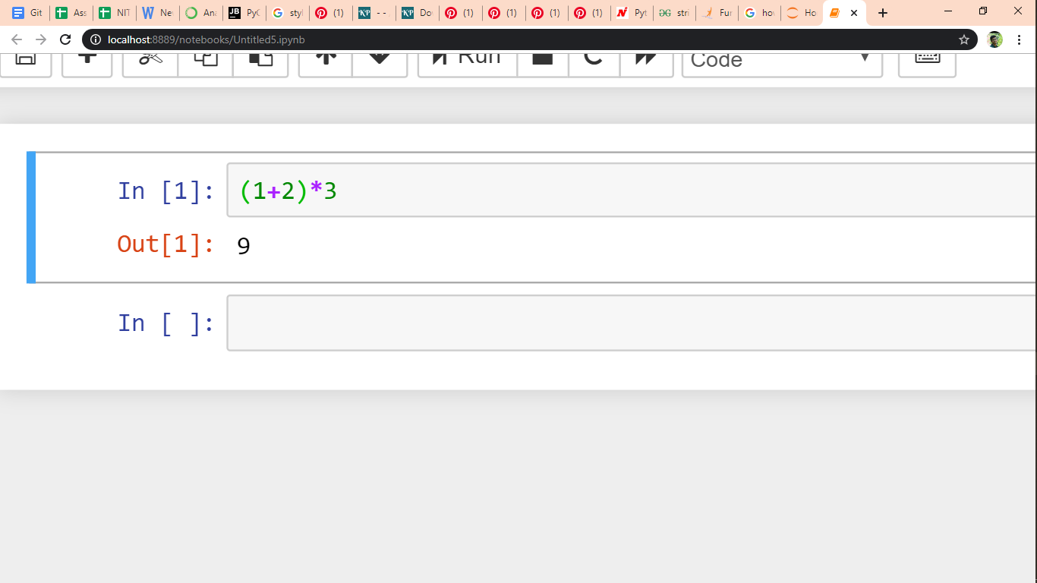Using simple arithmetic Expression: -
2. 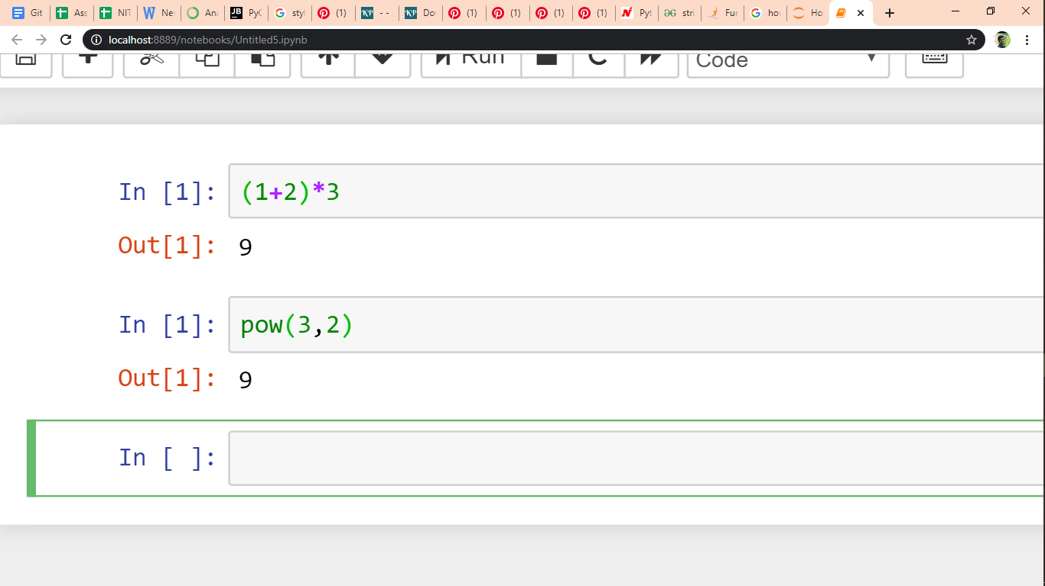sing Function in an Expression: -

## **Token**: -****

Tokens are the smallest unit of the program. There are following tokens in Python:

1. **Keywords**
2. **Identifiers**
3. **Literals**
4. **Operators**

* KEYWORDS: -

Keywords are nothing but a set of special words, which are reserved by python and have specific meanings. That the keywords are not allowed to use as variables in python.  
Keywords in python are case sensitive.

The different key word is: -

False, True, None, if, else, Not, Or, is, while, return, etc.…

* IDENTIFIERS: -

Identifiers in python are nothing but user-defined names to represent programmable entity like variables, functions, classes, modules or any other objects.

A Python identifier can be a combination of lowercase/ uppercase letters, digits, or an underscore. The following characters are valid: -

1. Lowercase letters (a to z)
2. Uppercase letters (A to Z)
3. Digits (0 to 9)
4. Underscore (_)

* LITERALS: -

The different literals are: -

1. String literals: -

A string literal is a sequence of characters surrounded by quotes.

1. Numeric literals: -

There are 3 types of literals such as Integer, Float, Complex.

1. Boolean literals: -

E.g.: - True, False

1. Collection literals: -

There are four different literal collections List literals, Tuple literals, Dict literals, and Set literals.

1. Special literals: -

Python contains one special literal i.e. None. We use it to specify to that field that is not created

1. Punctuator: -

Symbols like ‘#’, ‘(‘, ‘[‘, ‘=’ etc.

* OPERATORS: -

There is different type of operators are: -

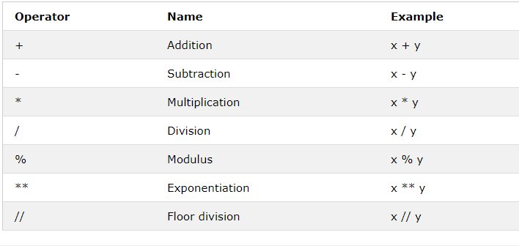Arithmetic Operators: -

Assignment Operators: -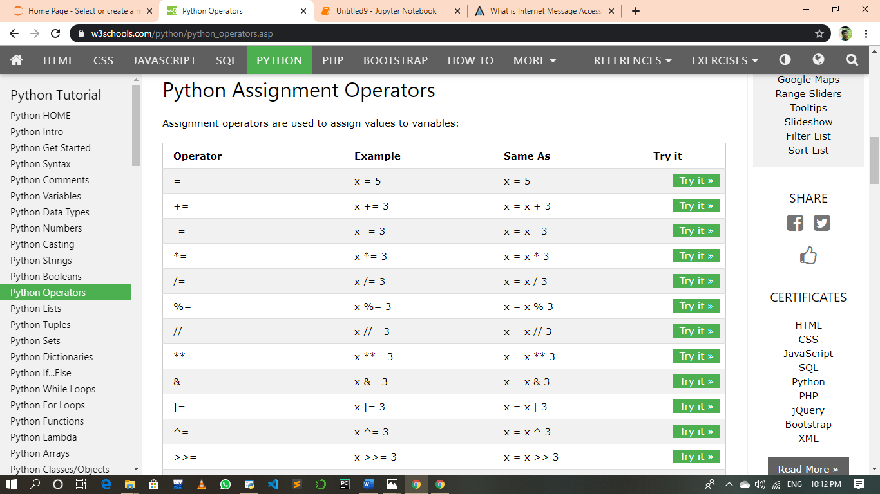

Logical Operators: -

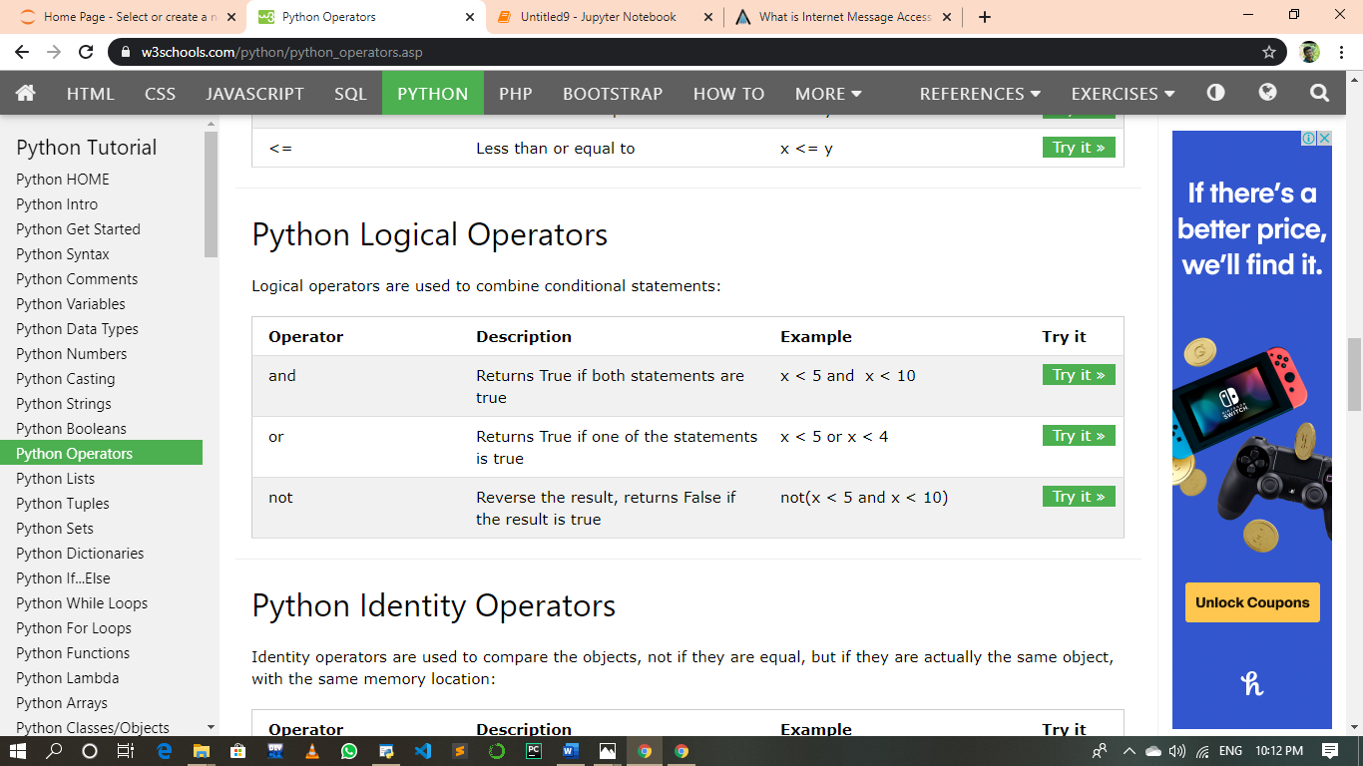

Membership Operators: -

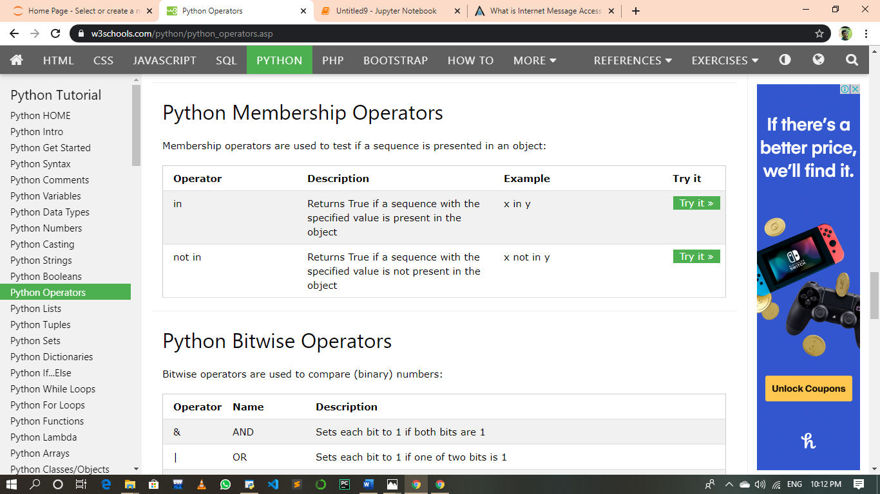

Identity Operators: -

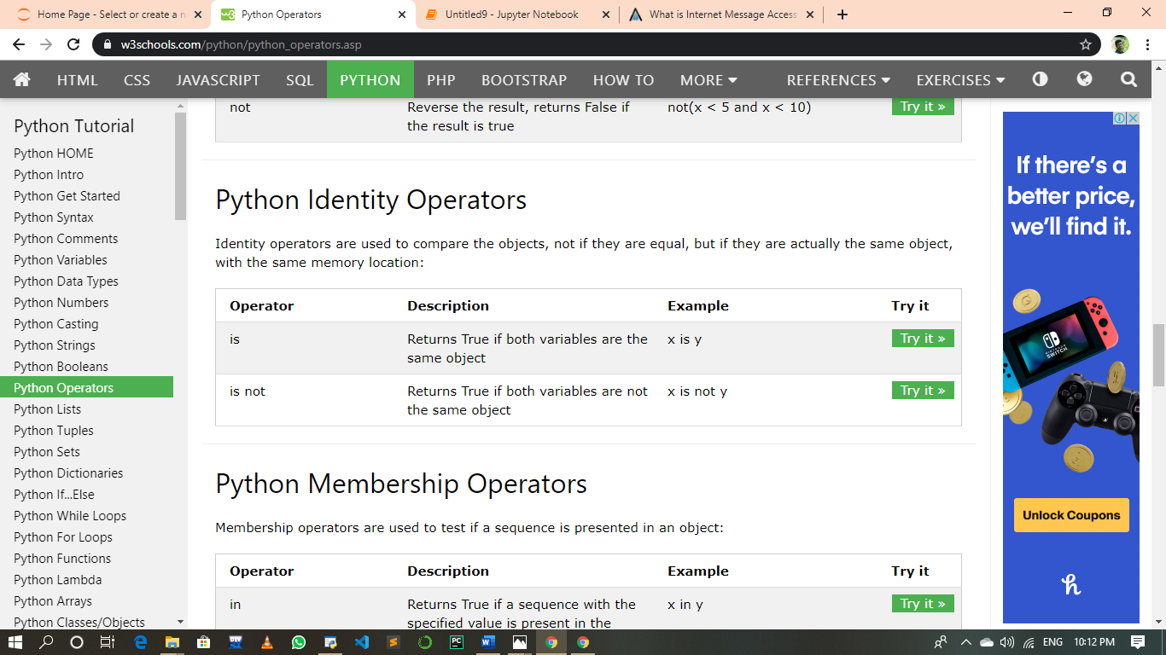

Bitwise Operators: -

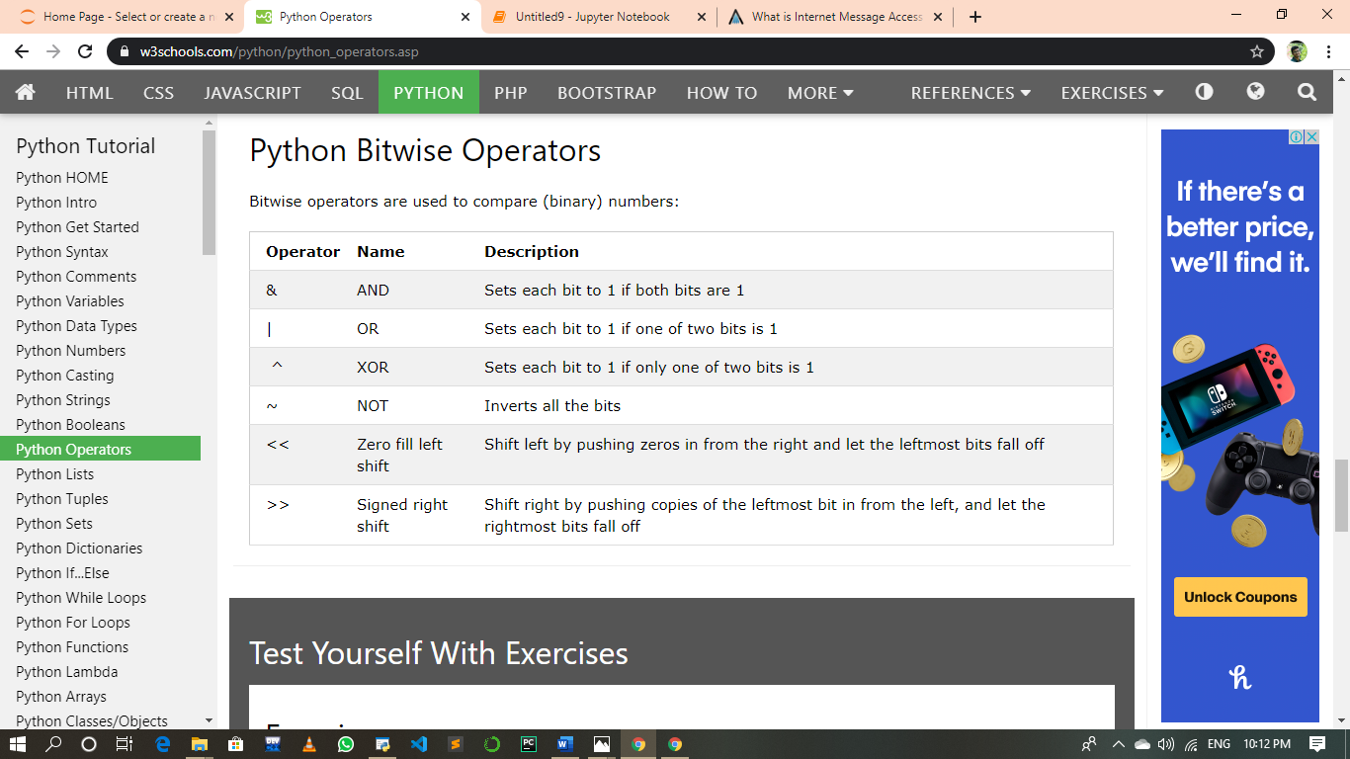

* PYTHON PROGRAMME: -
* COMMENTS: -

A comment in Python starts with the hash character, #, and extends to the end of the physical line. A hash character within a string value is not seen as a comment, though. To be precise, a comment can be written in three ways - entirely on its own line, next to a statement of code, and as a multi-line comment block.

* STATEMENTS: -

Some instructions are written in source code for the executions is called as the statements. There are diff types of the statements such as: -

1. Expression Statements
2. The Pass Statements
3. The Del Statements
4. The Return Statements
5. The Break Statements
6. The Continue statements

* BLOCK: -

Block is defined as a lexical structure of the source code which are grouped together, it consists of one or more declarations and statements.

For e.g.: -

A=5;

B=6;

C=A+B;

print(c);

In the above example shows a small block of codes.

* INDENT: -

Indentation in Python refers to the (spaces and tabs) that are used at the

beginning of a statement. The statements with the same indentation belong

to the same group called a suite.

* PYTHON STYLE RULES AND CONVENTIONS: -

* Constants are written in uppercase letters
* Classes follow the capitalized words convention
* Statement terminated
* There are some naming conventions are present such as: -
  + Functions (which are present in the lower-case characters)
  + Packages (which should be present all in lowercase characters)
  + Modules (which also present in lower case characters) etc.
* VARRIABLE AND ASSIGNMENTS: -

A Python variable is a reserved memory location to store values. In other words, a variable in a python program gives data to the computer for processing. Every value in Python has a datatype. Different data types in Python are Numbers, List, Tuple, Strings, Dictionary, etc.

Python lets you create variables simply by assigning a value to the variable, without the need to declare the variable upfront. The value assigned to a variable determines the variable type. Different types may support some operations which others don't.

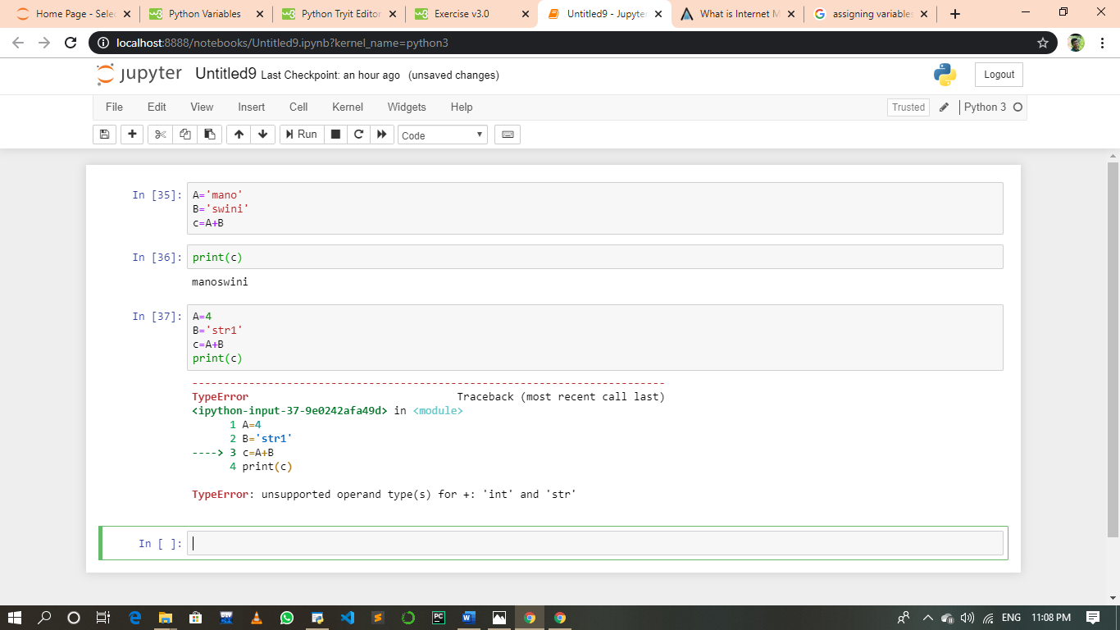

* INPUT AND OUTPUT: -

INPUT (): -

Python has an input function which lets you ask a user for some text input. You call this function to tell the program to stop and wait for the user to key in the data. In Python 2, you have a built-in function raw_input (), where as in Python 3, you have input ()

OUTPUT (): -

The simplest way to produce output is using the print () function where you can pass zero or more expressions separated by commas.

This function converts the expressions you pass into a string before writing to the screen.

D) DATA HANDLING: -

* + DATA TYPES: -

Data types are the classification or categorization of data items. Which checks the which type of data is it. i.e. it just works as the identifier.

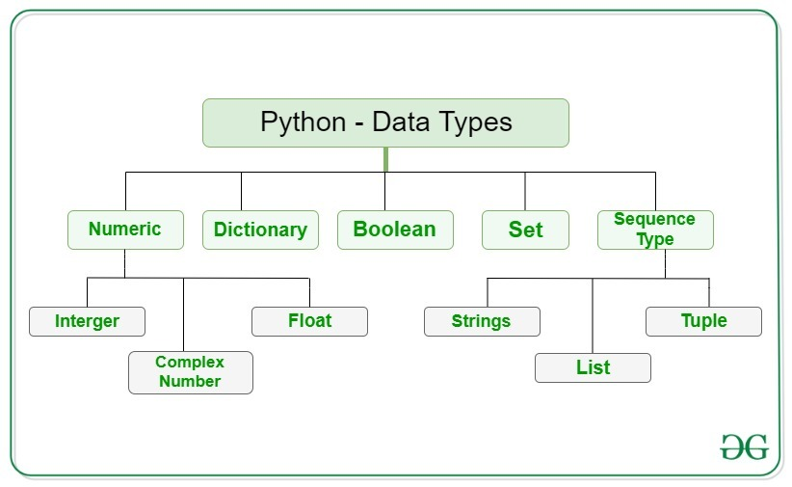

1. NUMERIC DATA TYPE CALCULATIONS:

Here, it shows only the three values such as integer, float, complex number identifier.

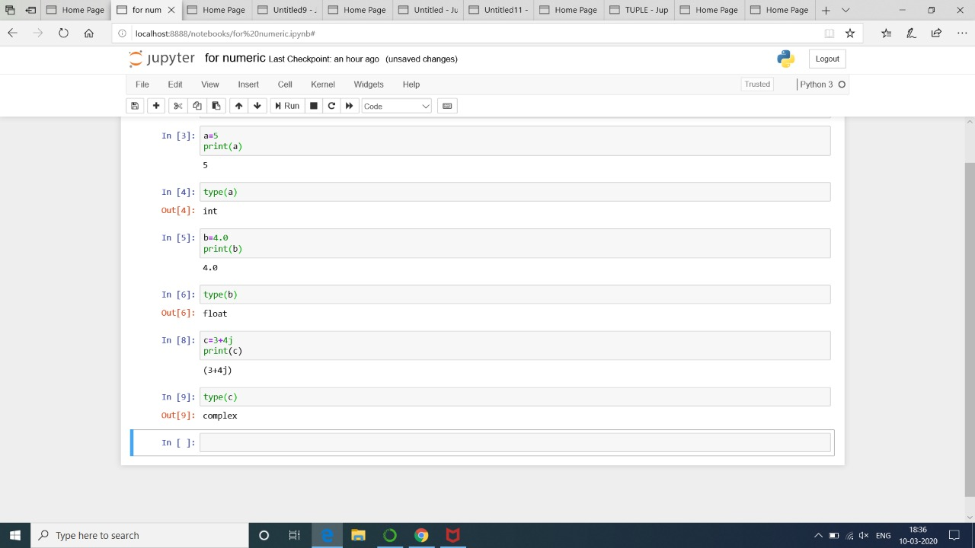

1. SEQUENCE TYPE: -

In python there are different data types are present in this can be again divided into three types for classify the data is;

## STRING: -

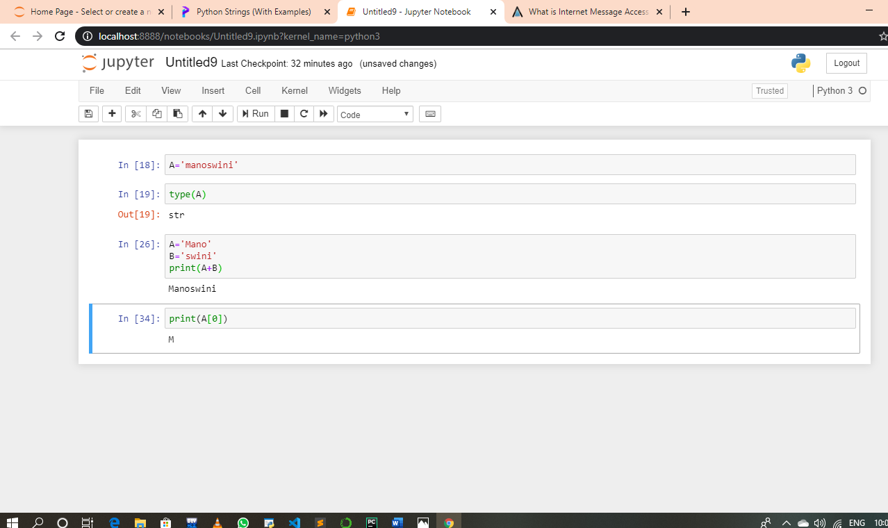In Python, Strings are arrays of bytes representing Unicode characters. A string is a collection of one or more characters put in a single quote, double-quote or triple quote. In python there is no character data type, a character is a string of length one. It is represented by str class.

* 1. **LIST: -**

Lists are just like the arrays, declared in other languages. Lists need not be homogeneous always which makes it the most powerful tool in Python.Lists are just immutable; hence it gets alter between them after it created. Each element in the list has its definite place in the list, which allows duplicating of elements in the list, with each element having its own distinct place and credibility. It is represented by list class.

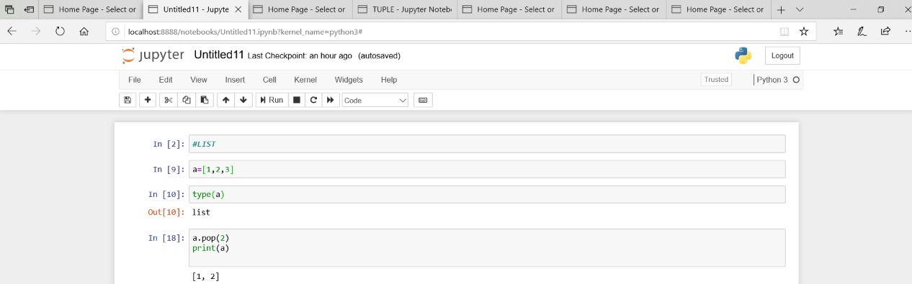

* 1. **TUPLE: -**

A tuple is a sequence of immutable Python objects. Tuples are sequences, just like lists. The differences between tuples and lists are, the tuples cannot be changed unlike lists and tuples use parentheses, whereas lists use square brackets. Creating a tuple is as simple as putting different comma-separated values.

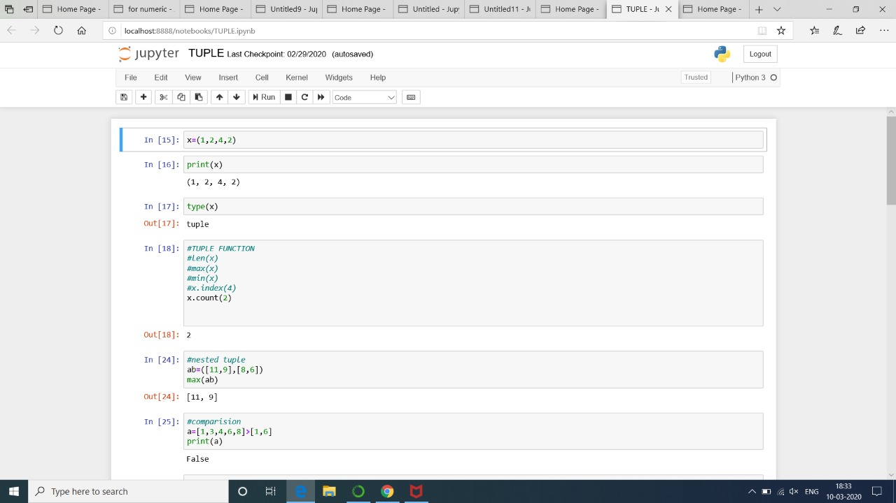

2.SETS: -

In Python, Set is an unordered collection of data type that is iterable, mutable and has no duplicate elements. You can add and delete elements of a set, you can iterate the elements of the set. A set object contains one or more items, not necessarily of the same type, which are separated by comma and enclosed in curly brackets {}.

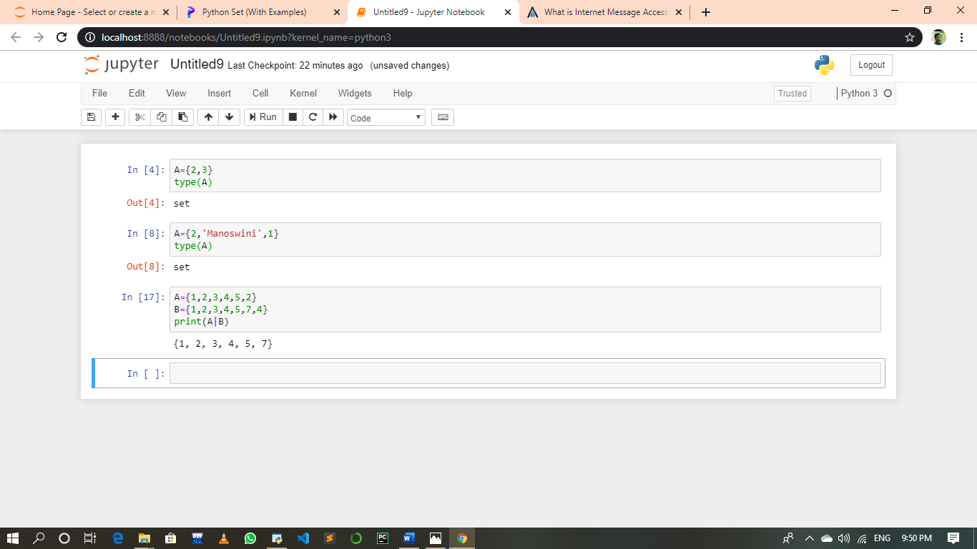

1. BOOLEAN: -

It can build up with 2 values, such as True or False. Boolean objects that are equal to True are truthy (true), and those equal to False are falsie (false). It is denoted by the class bool.

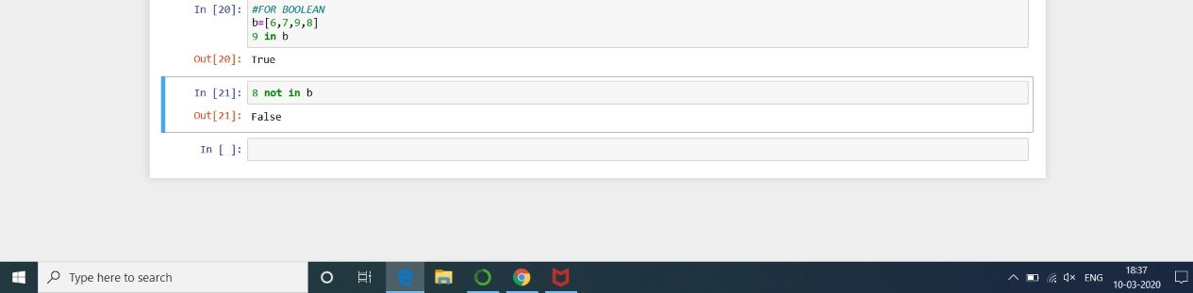Notice that 'T' and 'F' are capital.

1. DICTIONARY: -

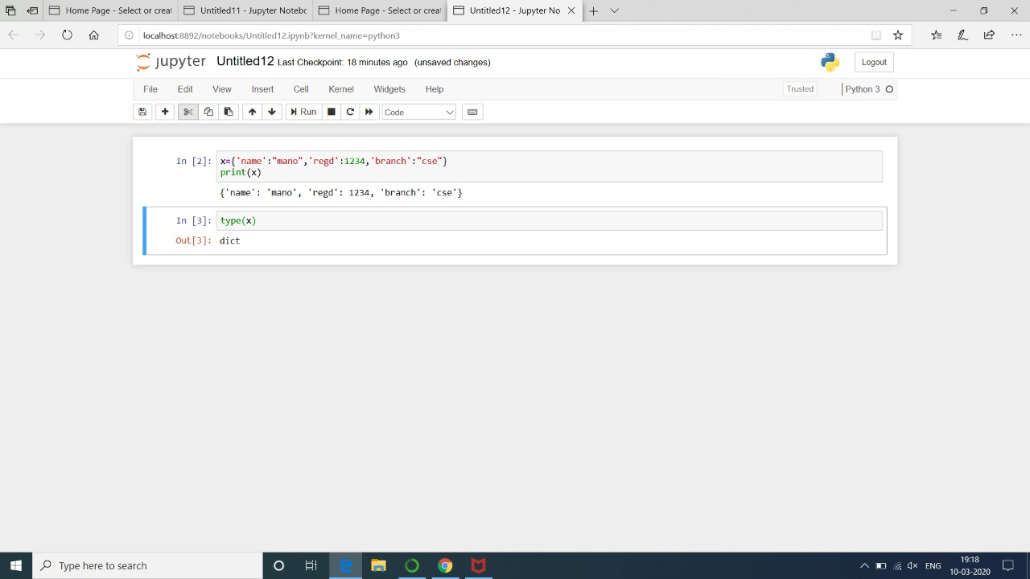Dictionary in Python is an unordered collection of data values, used to store data values like a map, Dictionary holds key: value pair. Key-value is provided in the dictionary to make it more optimized.  Each key-value pair in a Dictionary is separated by a colon :, whereas each key is separated by a ‘comma’.

* MUTABLE AND IMMUTABLE: -

There are two objects in the python language such as mutable and immutable.

MUTABLE: -

It is the objects of python which can be modified after its creation of the object. The examples of the mutable objects are sets, dict., list. IMMUTABLE: -

It is the objects of python which can’t be modified after its creation of the object. The examples of the immutable objects are tuple, Unicode, str, float, bool.

* Working with some libraries in Python: -

This is how you can use the Python standard library as well. Simply put, a module is a file consisting of Python code by.

The import statement in Python.

* More on import statements.
* Module Search Path.
* Byte Compiled Files.
* Writing Modules.
* The dir. () function

Some top of the python libraries: -

* Pandas
* Theano
* Scipy
* Eli5
* Light GBM
* TensorFlow